FACE RECOGNITION USING TRANSFER LEARNING

Step 1: Here I used cv2 module to capture photos and harcascade for human face recognition , these photos are used for training the model

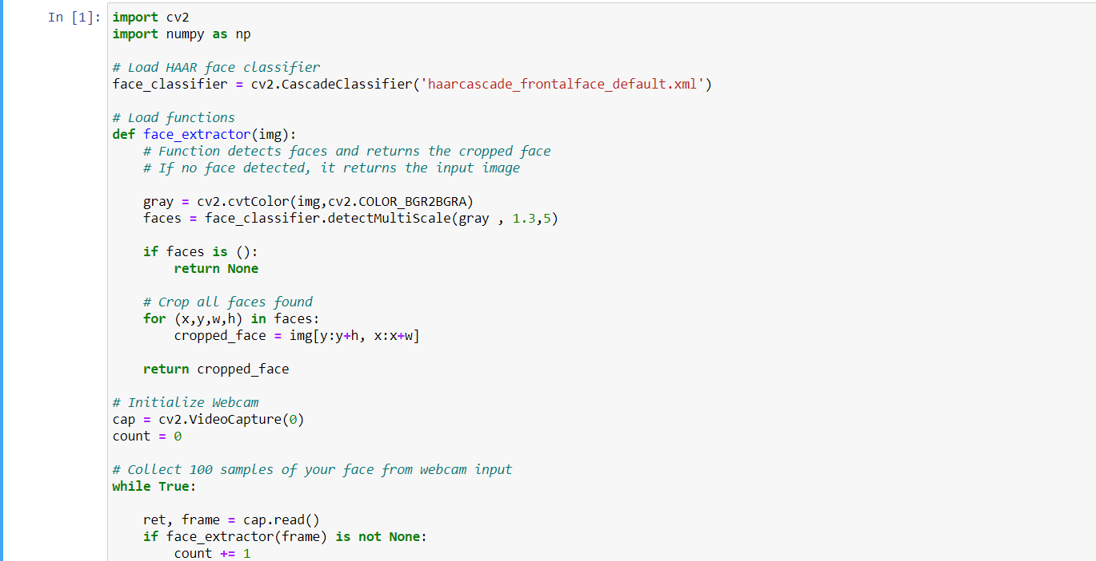

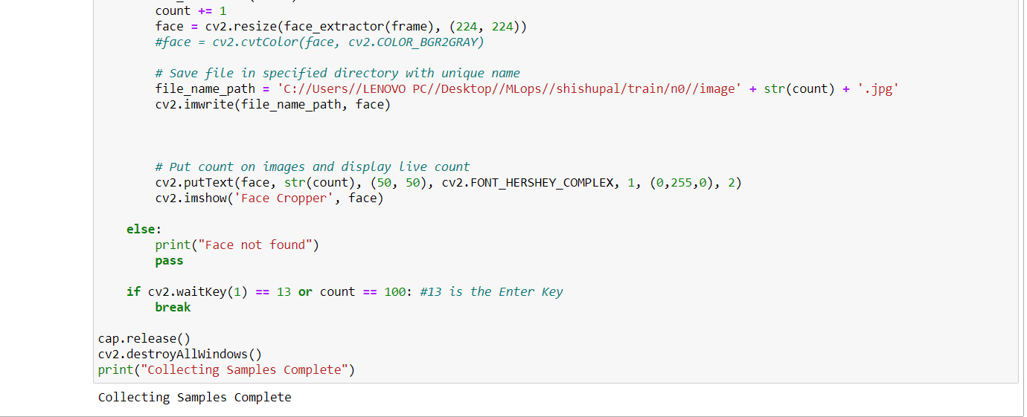

Step 2 Here we again collected the images data for testing

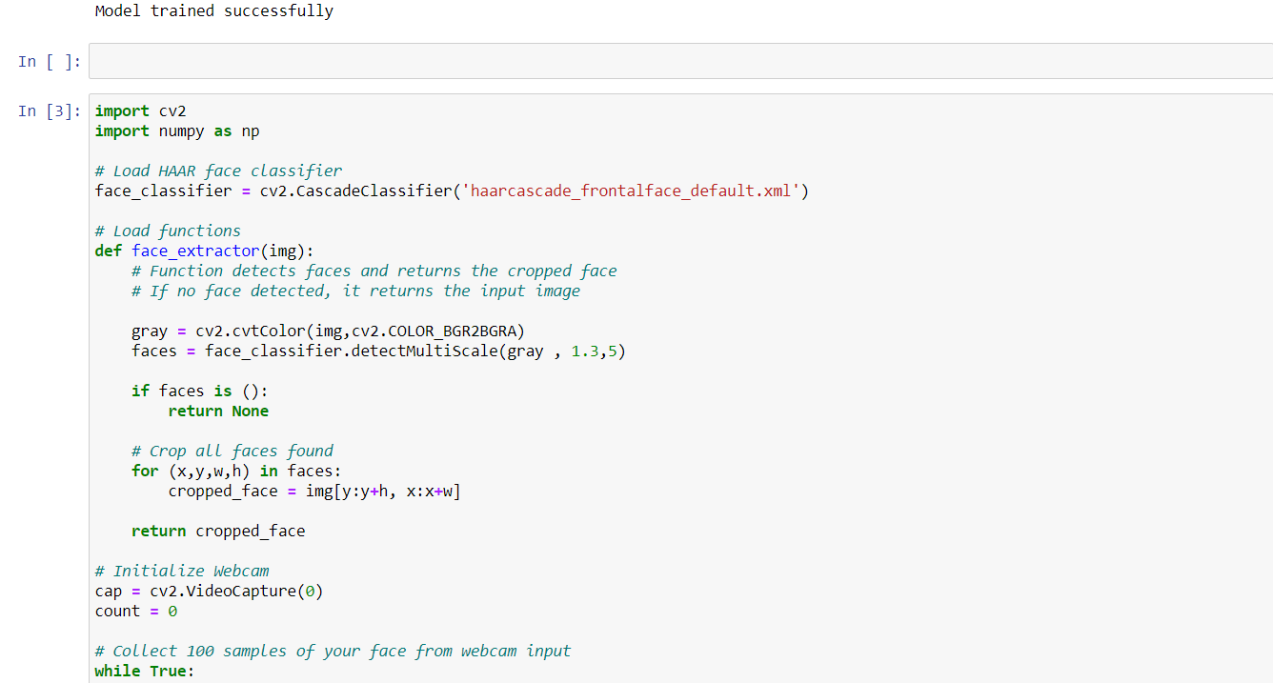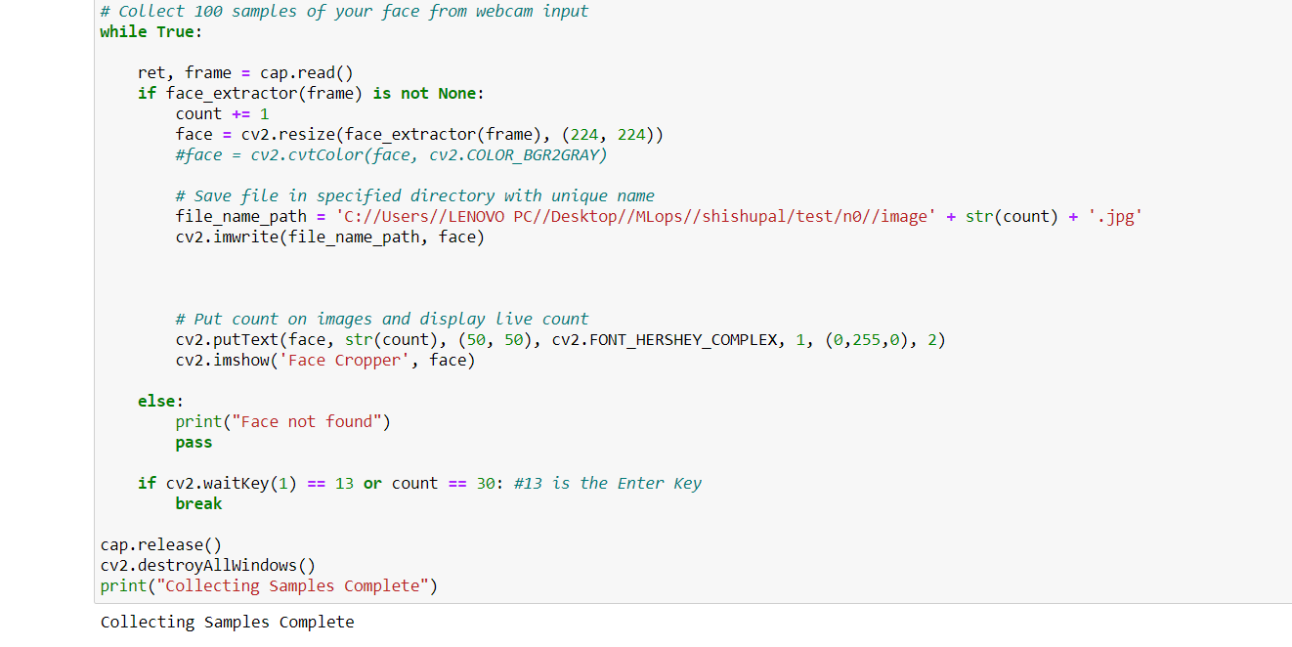

Step 3 Here we again collected data to train the model the model with another dataset of images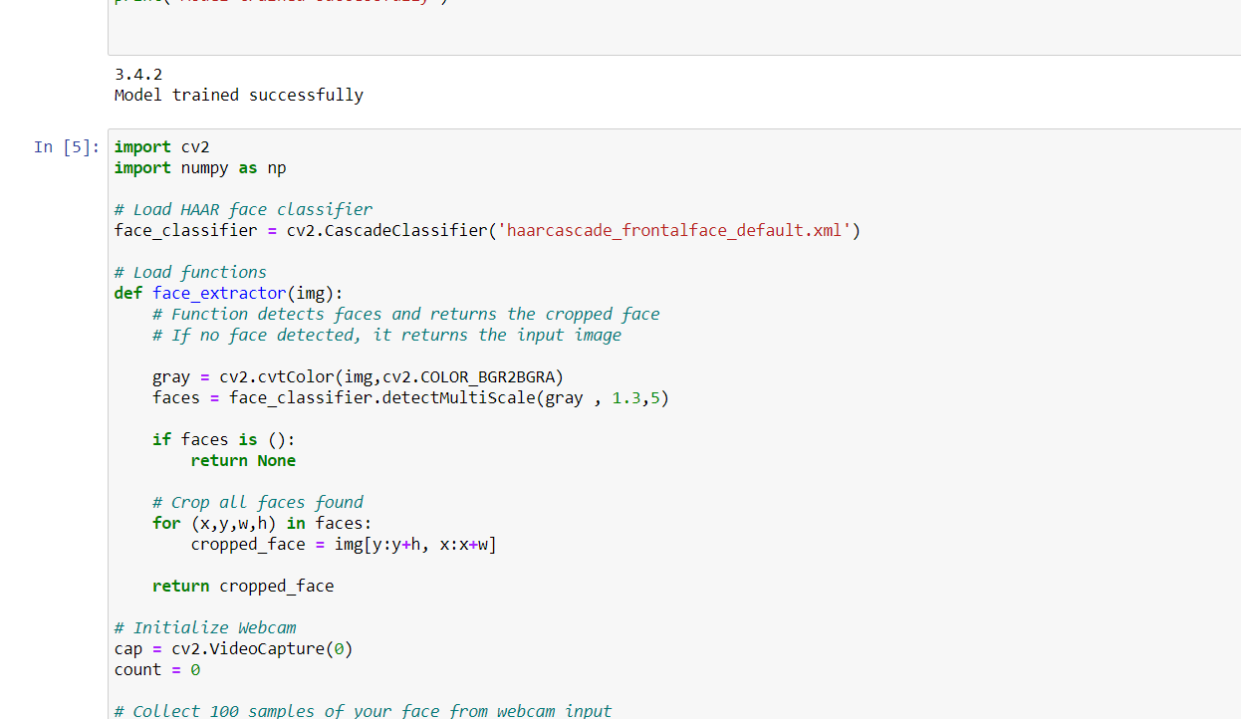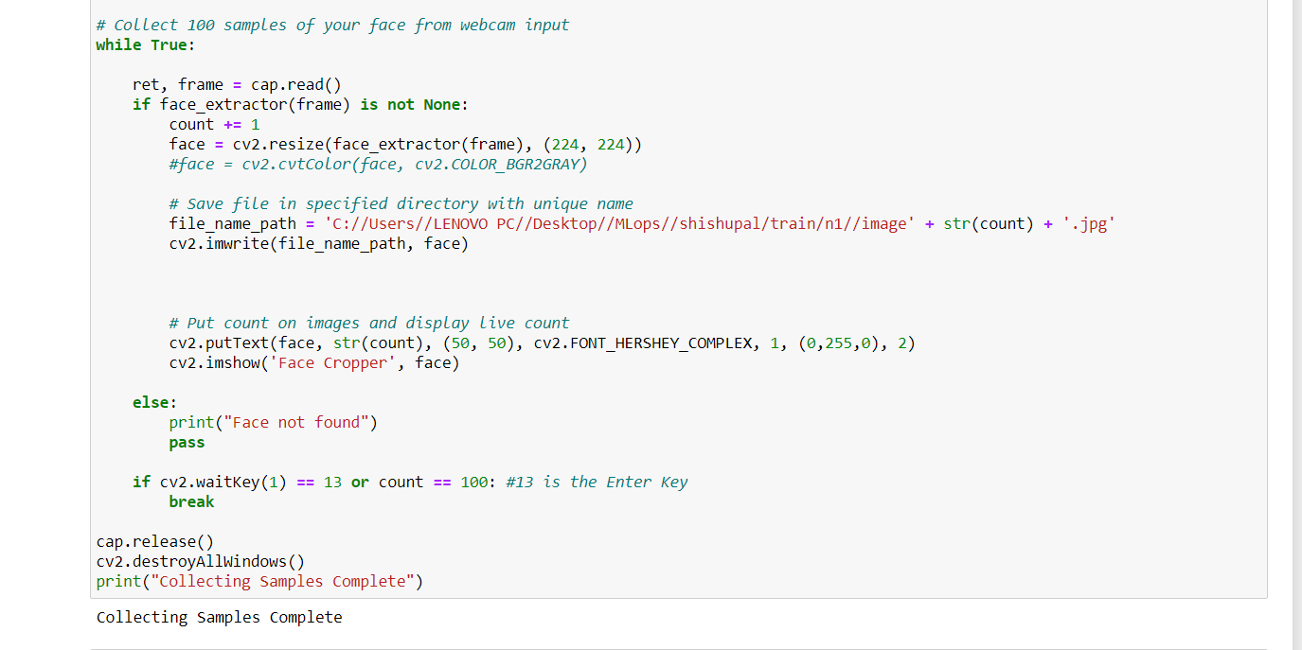Step 4 Here the data is collected for testing with another dataset images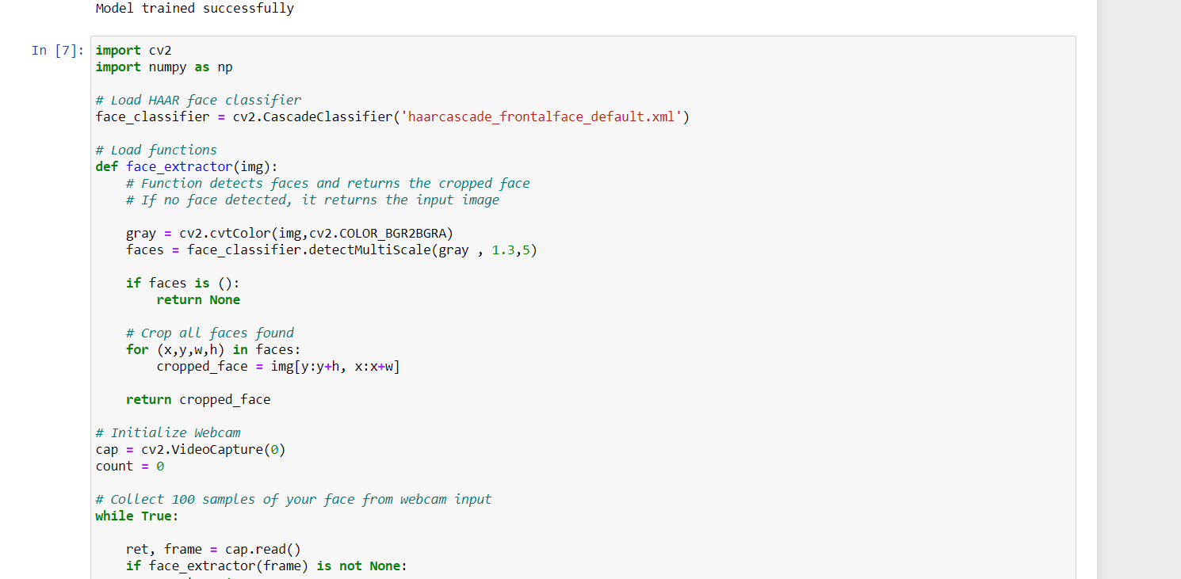

Step 5 Here I have pretrained model with pretrained weights , model I used is imagenet and made this layer of model as non trainable

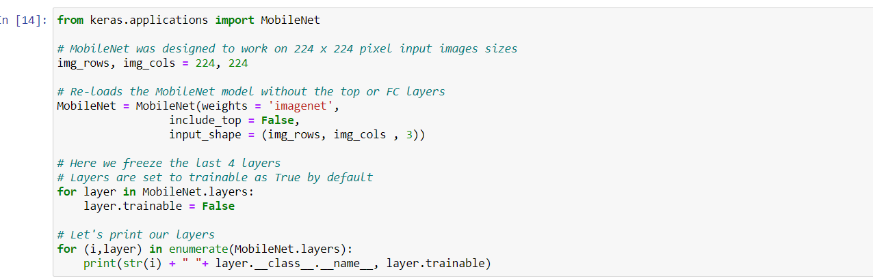

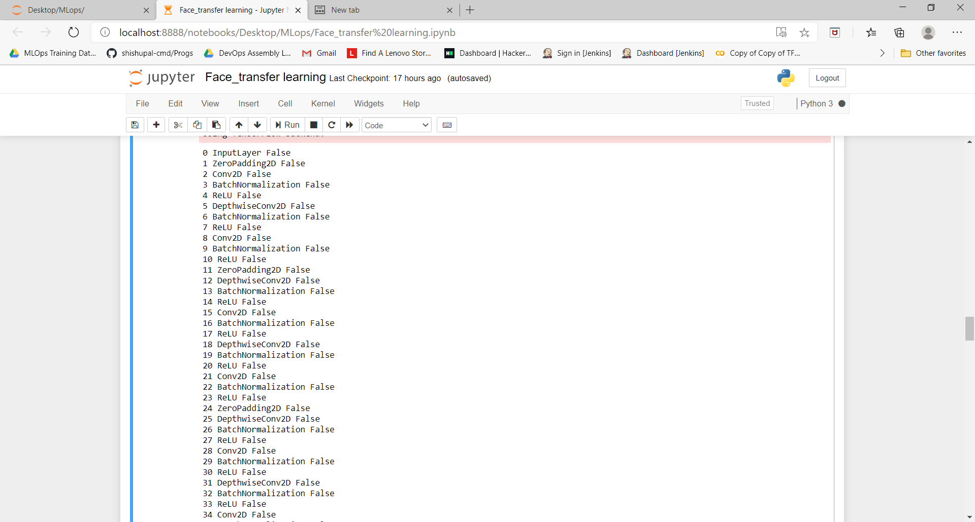

Step 6 Here I have imported the model and CL layer,PL layer and see the summary

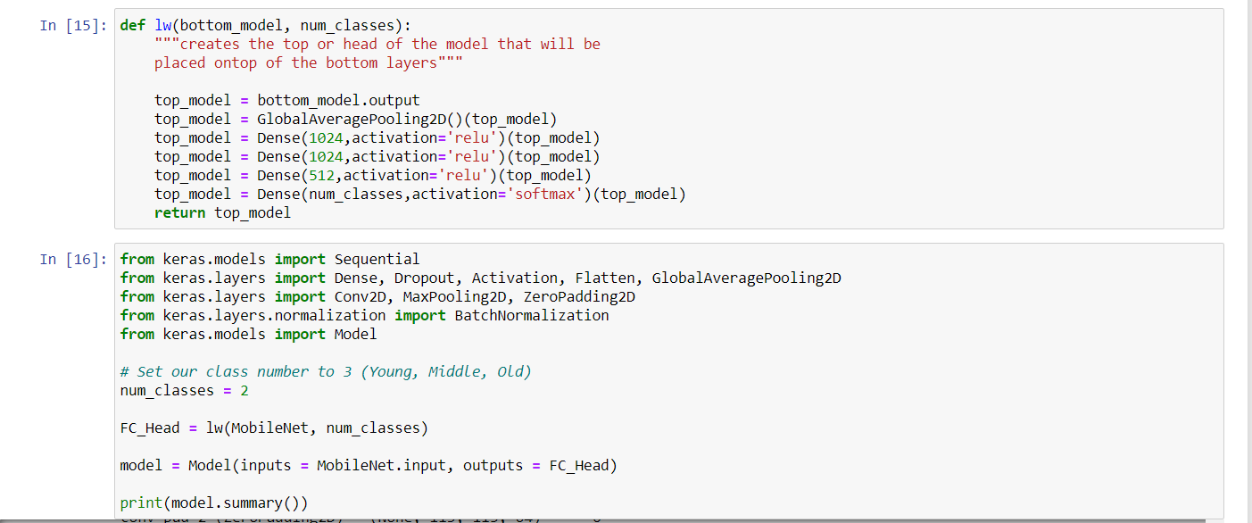

Step 7 Now here I did augmentation as data is less and add the image generator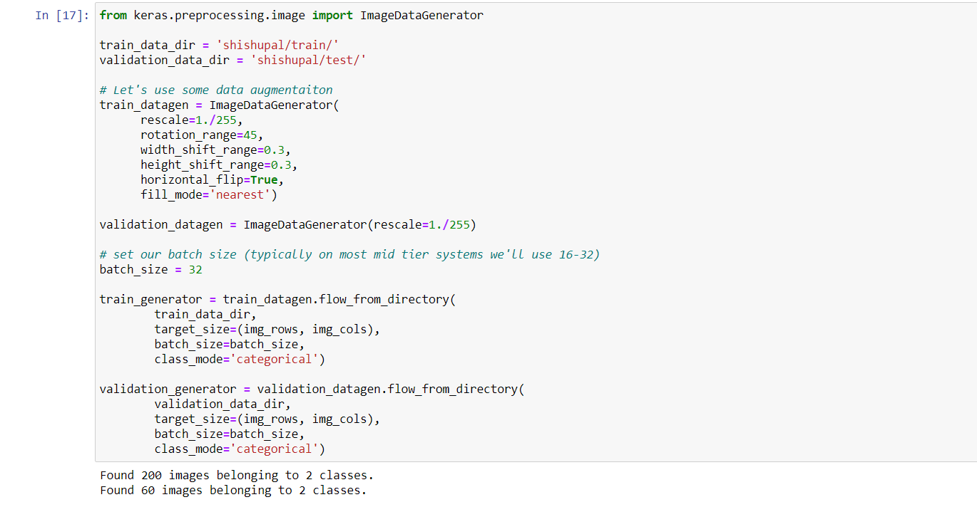

Step 8 Now here I compiled the model and did the epochs

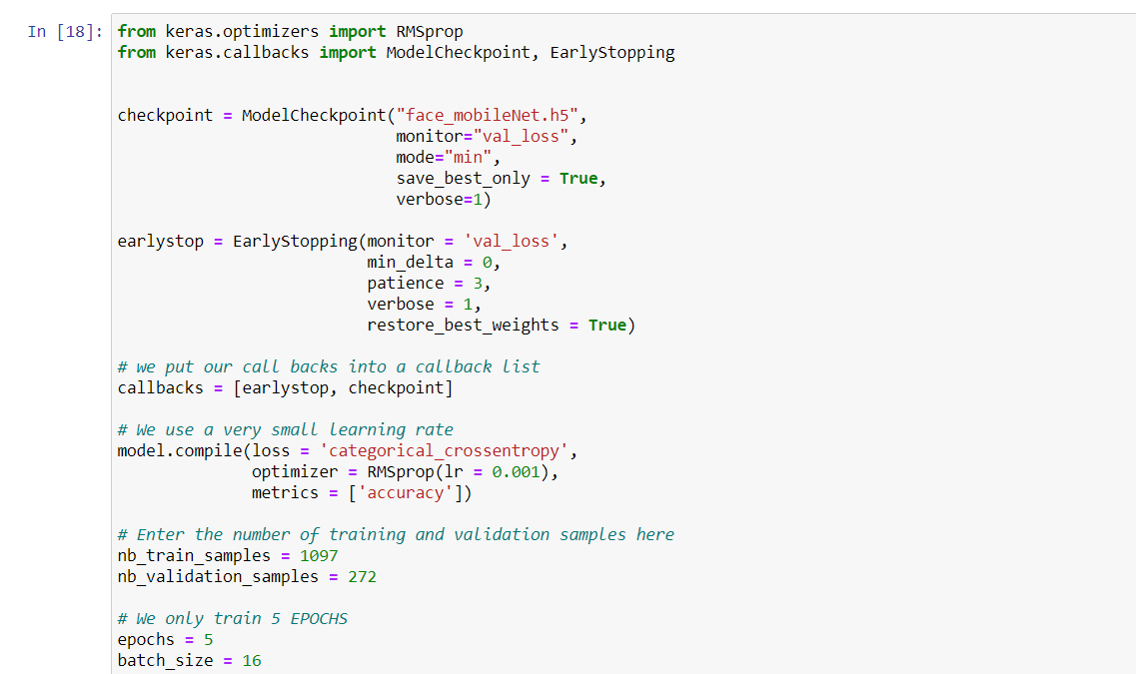

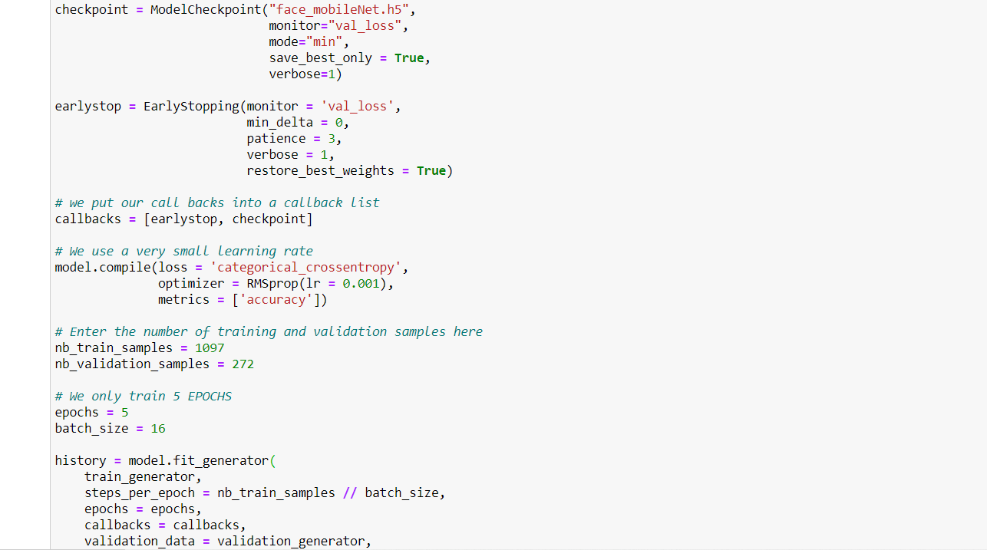

I have done 5 epochs and got 98% accuracy

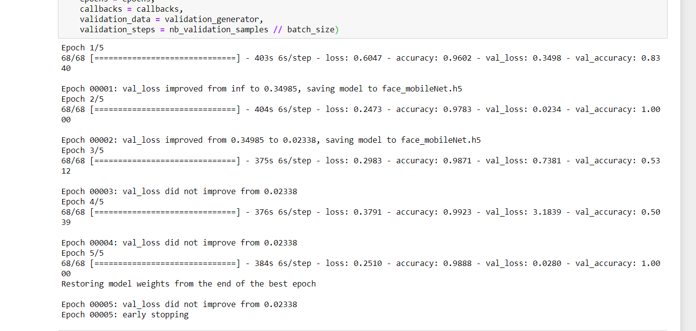

Step 9 Here I have load the model from face_mobilenet.h5 file and did the prediction with image output